CHEM 330 02 BIOLOGICAL CHEMISTRY
FALL 2024- Exam #1
Name:……………………………………………………………………………………………………..
A) Multiple Choice Section. 20 questions. 2.5 points each. Only one correct option (except question 9). 1.5 min/question

1) Benzoic acid is more soluble in an aqueous solution of:
- 0.1 M HCl
- 0.1 M NaCl
- 0.1 M NaOH
- 0.1 M CH3COOH (weak acid)
- 0.1 M Tris base (weak base)
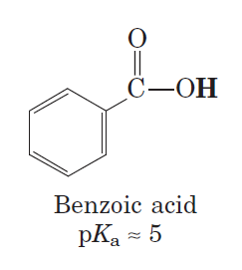
2) In the energetics of transferring hydrocarbons from water to nonpolar solvents (during hydrophobic clustering), the term TΔS is typically:
A) negative
B) positive
C) unmeasurable
D) unimportant
E) assumed to be zero

3) Which of the following is not an appropriate description for van der Waals interactions?

A) They involve dipole-dipole interactions.
B) Their strength depends on the distance between the two interacting atoms.
C) They are highly specific.
D) An individual van der Waals interaction does not contribute significantly to the stability of a globular protein.
E) They can involve hydrophobic amino acids.

4) In a highly basic solution, pH = 13, the predominant form of glycine is:

A) NH₂—CH₂—COOH
B) NH₂—CH₂—COO⁻
C) NH₂—CH₃⁺—COO⁻
D) NH₃⁺—CH₂—COOH
E) NH₃⁺—CH₂—COO⁻

5) Titration of isoleucine by a strong base, for example NaOH, reveals two pKas. The titration reaction occurring at pH=pKa1 (pKa1=2.4) is:
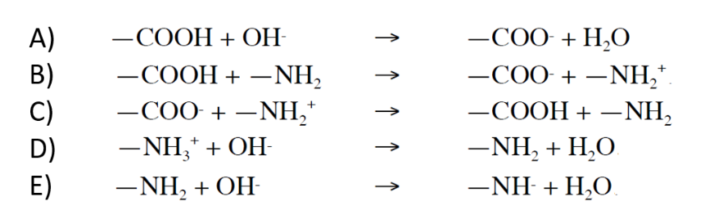

6) Which of the following amino acids has more than one chiral carbon?

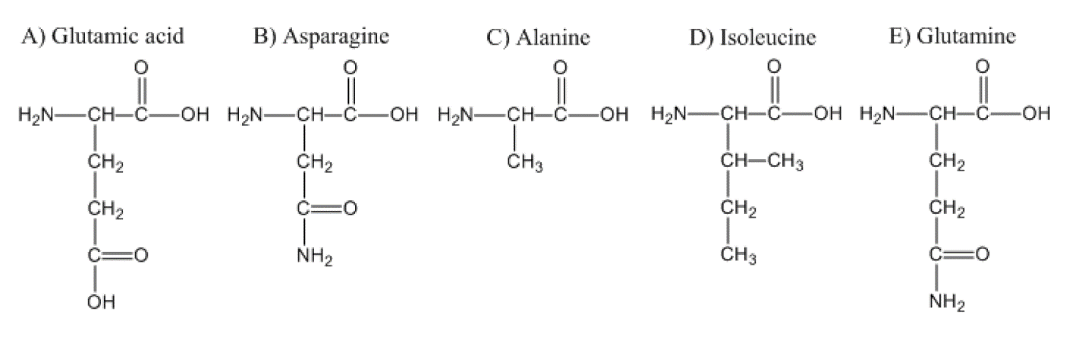

7) Which of the following amino acids is most commonly found at the core of a globular protein?
A) Serine
B) Lysine
C) Leucine
D) Tyrosine
E) Glutamine

8) Which sequence of atoms can be found in the backbone of polypeptides?
A) -C-N-N-C-
B) -C-C-C-N-
C) -C-C-N-C-
C) -N-C-C-C-
D) -C-O-C-N-

9) Given the following dipeptide:
Circle the atom(s) contained within one peptide plane (more than one choice is possible).

10) The Ramachandran plot below depicts the conformation of a region of the streptavidin protein (the dots represent experimental values of rotation angles psi and phi of each amino acid in the region):

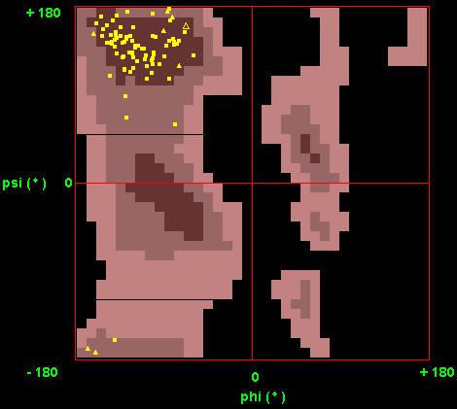
Based on the information in this plot, most amino acids fold into:

A) α helices;
B) β-sheets;
C) α-helices and β-sheets;
D) It is not possible to tell from a Ramachandran plot
11) What would you expect about the formation of an α‐helix for a segment of a protein chain that contains lysine approximately every fourth residue with all other residues being mostly hydrophobic?

A) Helix formation would never occur regardless of pH.
B) Helix formation would be favored at high pH.
C) Helix formation would be favored at low pH.
D) Helix formation would be favored at neutral pH.
E) Helix formation would always occur regardless of pH.

12) For the portion of a peptide shown below, which of the following statements is true

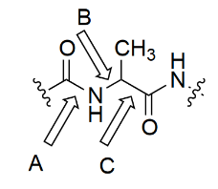
A) arrow A points to the bond that defines the phi rotational angle, B points to the bond that defines the psi rotational angle
B) arrow B points to the bond that defines the phi rotational angle, C points to the bond that defines the psi rotational angle
C) arrow C points to the bond that defines the phi rotational angle, A points to the bond that defines the psi rotational angle
D) arrow C points to the bond that defines the phi rotational angle, B points to the bond that defines the psi rotational angle
E) arrow A points to the bond that defines the phi rotational angle, C points to the bond that defines the psi rotational angle

13) Which of the following characteristics does not describe a beta sheet?
A) The beta sheet is stabilized by hydrogen bonds between different strands.
B) The strands in a beta sheet can be either parallel or antiparallel.
C) Beta sheets are typically composed of a single continuous strand of amino acids.
D) The R groups of the amino acids in a beta sheet alternate above and below the plane of the sheet.
E) Beta sheets adopt a pleated or zigzag appearance influenced by the phi and psi angles having large and opposite signs

14) Which one of these characteristics is not true for the α helix?
A) There are 3.6 amino acids per turn.
B) There is a requirement for glycine every third amino acid residue.
C) A hydrogen bond forms between the carbonyl oxygen of the nth amino acid residue and the -NH group of the (n + 4)th amino acid residue.
D) Proline is typically not found in the α helix.
E) It is right-handed.

15) The bonds or interactions that do not stabilize the quaternary structure of proteins are:
A) Hydrogen bonds
B) Ionic bonds
C) Hydrophobic interactions
D) Peptide bonds
E) Disulfide bonds

16) A cysteine residue in a protein active site has a pKa of 7.6 (referring to the deprotonation of the –SH groups as shown below). What percentage of the cysteines is deprotonated (-S-) at pH 7.0?
Cys-SH Cys-S- + H+
A) 80%
B) 60%
C) 25%
D) 20%
E) 50%

17) You are tasked with separating four proteins with molecular weights of 2 kDa, 4 kDa, 30 kDa, and 200 kDa. Which type of Sephadex would be most appropriate to completely separate these proteins, based on its fractionation range?
A) Sephadex G-25 (fractionation range: 1–5 kDa)
B) Sephadex G-50 (fractionation range: 1.5–30 kDa)
C) Sephadex G-75 (fractionation range: 3–80 kDa)
D) Sephadex G-100 (fractionation range: 4–150 kDa)

18) Given a threonine and two water molecules, hydrogen bonding exists between which pairs of atoms?
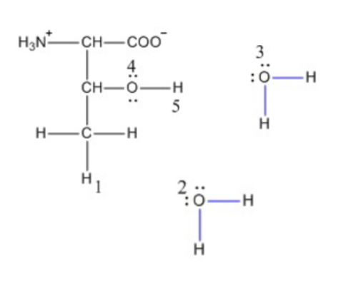
A) (1,2) & (3,5)
B) (1,2) & (3,4)
C) (4,5)
D) (3,5)
E) (2,3)

19) You are performing ion exchange chromatography on four peptides. Which of the following peptides is expected to bind most strongly to a cation exchange resin at pH 7.0?

A) Peptide A: Sequence - ASP-GLU-SER-ASN
B) Peptide B: Sequence - LYS-ARG-LYS-GLY
C) Peptide C: Sequence - ALA-SER-GLY-THR
D) Peptide D: Sequence - GLU-LYS-SER-ASP
E) Peptide E: Sequence - LYS-ARG-LYS-ASP

20) Lysosomes are acidic compartments that degrade macromolecules, such as proteins and lipids. The acidic pH (5) in this compartment is crucial for activating hydrolytic enzymes that function optimally at this low pH. You want to mimic the lysosomal compartment in a test tube. What buffer should you use?
A) Phosphate buffer (pKa=7.2)
B) Tris buffer (pKa=8.1)
C) Citrate buffer (pKa=4.8)
D) Hepes buffer (pKa= 7.6)
E) MES buffer (pKa=6.2)

B) Short Answers Section- 5 questions- 10 points each- 4 minutes each
1) The octapeptide:
ala-glu-ala-glu-ala-lys-ala-lys
forms a stable alpha-helical structure in solution at pH 7.0 (Saiani, A., et al. "Self-assembly and gelation properties of α-helix versus β-sheet forming peptides." Soft Matter 5.1 (2009): 193-202.). Mention ALL the factors that help to stabilize the alpha-helix structure of this octapeptide.

- Draw the resonance structure of a peptide bond and explain why there is no rotation around the C—N bond.

- Segments of a parallel (left) and antiparallel (right) beta sheet are shown below:
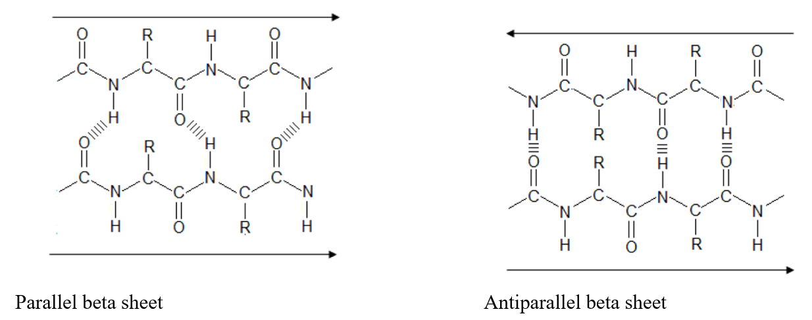
What structure would be more stable, a parallel beta sheet, or an antiparallel beta sheet? Explain in detail.

4) The figure below describes the titration curve for aspartate. Aspartate has three ionizable groups and therefore three different pKa’s.
i) On the curve below mark the pKas with a square and label each square with the appropriate pKa value.

ii) Calculate the pI value for aspartate. Show your work.

5) i) Draw the dipeptide Ala-Lys at pH=7.0.

ii) What is the charge on this dipeptide at pH=12? For this dipeptide, pKaα-COOH=2.18; pKaα-NH₂= 8.95; pKaR= 10.53. Justify your answer.

